การบ้าน #1 ER to DDL (SQL)

CREATE TABLE order_item (

id int auto_increment,

amount int not null,

discount int not null,

PRIMARY KEY (id)

);

CREATE TABLE Orders (

id int auto_increment,

date_order varchar(60) not null,

contain int not null,

PRIMARY KEY (id),

FOREIGN KEY (contain) REFERENCES order_item (amount)

);

CREATE TABLE employee (

id int auto_increment,

name varchar(60) not null,

address varchar(60) not null,

salary int not null,

sold int not null,

PRIMARY KEY (id),

FOREIGN KEY (sold) REFERENCES Orders (id)

);

CREATE TABLE product (

id int auto_increment,

name varchar(60) not null,

desc_product varchar(60) not null,

price int not null,

quantity int not null,

refer int not null,

PRIMARY KEY (id),

FOREIGN KEY (refer) REFERENCES order_item (id)

);

CREATE TABLE customer (

id int auto_increment,

name varchar(60) not null,

address varchar(60) not null,

place varchar(60) not null,

PRIMARY KEY (id),

FOREIGN KEY (place) REFERENCES Orders (id)

);

create table department (

id int auto_increment,

name varchar(60) not null,

budget varchar(60) not null,

emp_dept int not null,

primary key (name),

FOREIGN KEY (emp_dept) REFERENCES employee (id)

);

CREATE TABLE supplier (

name varchar(60) not null,

address varchar(60) not null,

phone_number int not null,

prod_sup varchar(60) not null,

PRIMARY KEY (name),

FOREIGN KEY (prod_sup) REFERENCES product (id)

);

การบ้าน #3 Sub Query

SELECT student_id, students.name, SUM(price), COUNT(*)

FROM (

select * from enrolls

INNER JOIN courses ON enrolls.course_id = courses.id

) as new_table

INNER JOIN students ON students.id = new_table.student_id

GROUP BY new_table.student_id

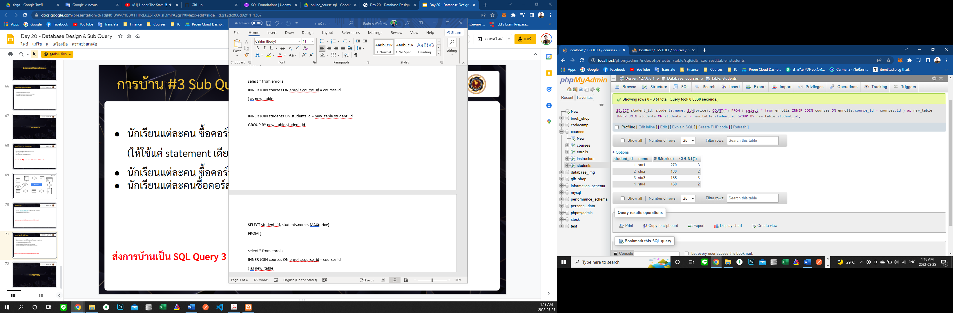

SELECT student_id, students.name, MAX(price)

FROM (

select * from enrolls

INNER JOIN courses ON enrolls.course_id = courses.id

) as new_table

INNER JOIN students ON students.id = new_table.student_id

GROUP BY new_table.student_id

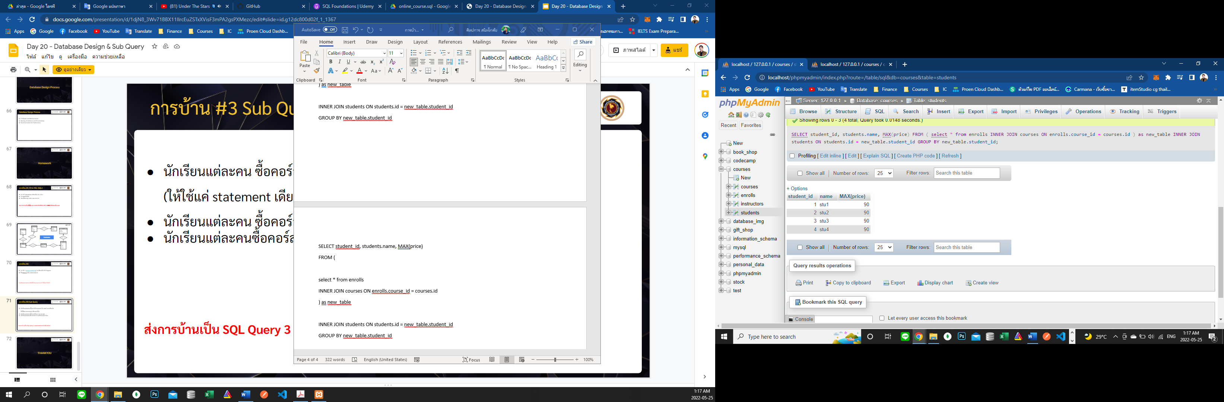

SELECT student_id, students.name, AVG(price)

FROM (

select * from enrolls

INNER JOIN courses ON enrolls.course_id = courses.id

) as new_table

INNER JOIN students ON students.id = new_table.student_id

GROUP BY new_table.student_id

